**Turbomachines** are rotary equipment like turbines (steam, gas, hydraulic), pumps, fans, blowers, compressors.

A turbo machine is a device in which energy is transferred between a flowing fluid and rotating element (rotor). While a turbine transfers energy from a fluid to a rotor, a compressor transfers energy from a rotor to a fluid.

Types of turbo machines on the basis of:

1. Energy transfer direction:
2. Power developing: turbine, fluid motors (Mechanical or electricity is produced from fluid)-decrease of enthalpy of fluid.
3. Power absorbing: Fan, jet propulsion, compressor, pump (Electricity is given and gives energy to fluid)-increase in enthalpy of fluid.

Fluid density change:

1. Hydraulic Machines: Constant density. E.g. water pumps, fans
2. Thermal Machines: Variable density: E.g. compressors, gas turbines (gas turbines expand a high-pressure stream to lower pressure extracting power from the fluid to rotate a shaft)
3. Flow direction:
4. Axial: When the flow is parallel to the [axis of rotation](https://en.wikipedia.org/wiki/Axis_of_rotation), they are called axial flow machines. E.g. axial turbine, axial compressor, etc.
5. Radial: when flow is perpendicular to the axis of rotation, they are referred to as radial. A radial flow machine may also be classified into radial inward flow (centripetal) or radial outward flow (centrifugal) types depending on whether the flow is directed towards or away from the shaft axis.
6. Mixed flow: Called mixed flow machines, where both radial and axial flow velocity components are present.

Turbocharger:

Turbocharger in vehicles harvest the waste energy present in the exhaust gases to increase the power output of an internal combustion engine.

In an internal combustion engine, air is sucked inside the cylinder due to the suction pressure. As the speed of the engine increases, the time available for sucking in air into the combustion chamber decreases so power developed also decreases. Also, in low atmosphere environment the pressure difference between outside and inside the chamber is less so less air is sucked.

This is where turbocharger comes into play. A turbocharger is used to push more air into the combustion chamber, so that the combustion chamber gets filled in a shorter time period. As more fuel is present inside the combustion chamber, more fuel can be burnt and hence more power can be produced or more power output.

Working:

In a turbocharger, a single shaft consists a compressor blade and a turbine. Gas from the exhaust port consists energy and is allowed to pass turbine of turbocharger so turbine gains rotational energy. Here, gas energy is transferred to the blades of the turbine.

Since, the shaft is fixed to both turbine and compressor, compressor also rotates as turbine rotates and the air is sucked from environment and is compressed and send it to the inlet of combustion chamber. Here, energy is supplied to the air and finally the compressor generates high pressure air.

The elaborated figure is shown below:

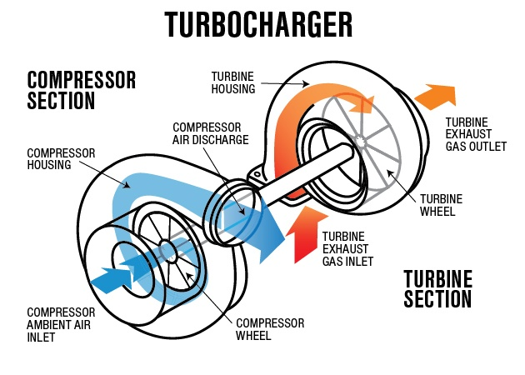

Parts of Turbo machine:

1. Rotating elements: Vane, impeller, buckets or blades
2. Stationary elements: Which usually guide the fluid in the proper direction.
3. Shaft: It either give input power or takes output power from fluid and runs at required speed.
4. Housing: To keep various rotating, stationery and other passages safely under dynamic conditions.

**Conservation of energy:** Change in total energy of control mass equals the heat added to the system minus the work produced by the control mass.

dE=dQ-dW

Total energy=Internal energy+ system (PE+KE)

Internal energy=energy of the system due to its molecular activity=summation of molecular PE and KE (vibration). As the molecular activity increases with temperature so the internal energy increases with temperature.

##**First law of thermodynamics for control mass.**

Q12=deltaU12+W12

#First law of thermodynamics for control mass **undergoing cyclic process**:

Since, initial and final state are identical:

Cyclic integration of (dQ=dW).

#First law of thermodynamics for control mass at constant volume:

dW=0

Q12=deltaU12

Heat added will increase the internal energy.

**Second Law of thermodynamic:**

First law explains the thermodynamic process with reference to mass and energy conservation. Deals with quantity.

It defines the direction of the process in which system can proceed i.e. isolated system will proceed in the direction in which randomness or uncertainty i.e. entropy increases.

Sfinal-Sinitial>=0

T.dS=dU-PdV🡪Gibbs Equation🡪Entropy relation